2019成人高考英语作文范文
1、你是张浩，一位办公室职员，成人高考英语作文范文。有时感到乏味，很容易疲倦。你想加入一个俱乐部，改变一下这种状况，以便闲暇时间过的更快活。写了一封信给俱乐部经理介绍你的嗜好和兴趣。
Dear Club Manager，
I am writing to ask to join your club to enjoy my free time.
I am a clerk. I often feel tense and become tired easily. Perhaps, I need to relax myself. I hope to become a member of your club. I have many hobbies and interests. For example, I like photography, painting, dancing and singing. And I like going fishing, collecting stamps and raising flowers. Besides, I am good at playing Chinese chess and cards. Please write back to me and I will have to go through.
Thank you very much in advance.
Looking forward to your reply.
Yours,
Zhang Hao

2、你是王萍，写一封信给Jefferson先生。信件的内容包括:
1、一个月前，他邀请了你到他家过圣诞节。
2、你在他那里受到了热情款待。
3、信件末尾写上一句你认为必要的话。
Dear Mr.Jefferson，
I am writing to thank you for your kindness and hospitality I enjoyed during my stay in your place.
It is very kind of you to invite me to spend my Christmas holiday in your palace last month. The room you arranged for me in your house was quiet, clean and comfortable. The food was very delicious. And visits to locals scenic spots were really wonderful. They have not only broadened my horizon, but also enriched my experience. By the way, if it is convenient for you, please come over and spend your Spring Festival this year in my place.
Thank you very much again.
Yours,
WangPing

3、你的朋友Glad要从另一个城市来看你。你将到机场去接他。但出于某种原因，你不能去了，写封信给他，解释原因，并告诉他如何到你家。
Dear Glad，
I am writing to say that I will not be able to meet you at the airport next Monday morning.
This morning my boss asked me to go to Shanghai on business tomorrow. It is something very important for our company and I will have to go. By the way, I will be back within 10 days. When you arrive, please take Bus No.345 and get off at the East Bus Station. The station is not far from my house and you will find my house easily. My mother is always at home. It old my mother that you would come already.
Looking forward to seeing you.
Yours,
LiMing

4、你是高明，不能在下周一下午四点与李青女士见面。写一封信给她，内容应包括:
1.向她表示歉意;
2.解释你的原因;
3.提出把约会时间推后三天;
4.写上一句你认为有必要写的话
Dear LiQing，
I am writing to say I’m sorry that I will not be able to go for the appointment at 4:00 p.m. on Monday next week.
This morning I got an urgent phone call from my boss in Guangzhou, and he asked me to flight there once to join him in an important business negotiation. The Negotiation has something to do with the future of our company. I will have to stay there for about a week. I hope to post pone the appointment for three days till Thursday next week. Phone me and let me know if it is ok to you. My apologies again.
Looking forward to seeing you.
Your friend,
GaoMing
5、你叫李平，是英语系学生会主席。写一封信给王教授，请他做一个有关中国历史的报告。注意信中要包括目的、时间、日期和地点。
May 19，2002
Dear Professor Wang,
On behalf of the Student Union of the English Department， I am writing to invite you to give a lecture on Chinese history.
We have planned to have such a lecture at 2：30 p· m. in Lecture Hall 419， on May 25.
Looking forward to your lecture. Inform us in advance if you can not come.
Sincerely yours，
Li Ping
6、你是Helen，要写一封信给Julie，对她和她的丈夫昨日请你和你丈夫吃饭表示感谢，表示要回请他们，以答谢他们的盛情款待。
Dear Julie，
Thank you very much for the dinner that you invited my husband and I to yesterday. The food not only looked and smelled fabulous but tasted great， and my husband and I enjoyed it very much. Therefore， we would like to invite you to dinner at 7 p·m. this Friday at the Northwest Chinese restaurant to return your kindness and hospitality.
Please do come.
Yours，
Helen
7、你是Alice.你的朋友Bonnie很快就要到你的乡间小屋拜访，但你却要出去一会儿。留一张便条给她，告诉她食品在哪儿，告诉她一个人在屋里时应注意些什么。
May 18， 2002
Dear Bonnie，
I will be away for a while. The key to the cottage is under the doormat， and the food is in the refrigerator. After entering the house， lock the door from inside at once. The cottage is far away from the nearest town， and the area is not quite safe from burglars. So I think the saying is right “Where there is precaution， there is no danger”。
Have a nice stay here.
Yours，
Alice

神翻译系列
“请在一米线外等候”被译成“Please wait outside a noodle”（在一条“米线”外等候）
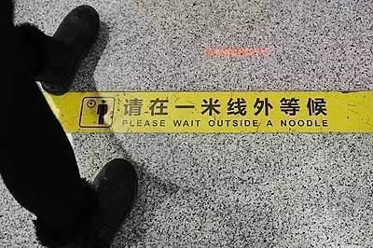
其实…真的不是英文学不好，只怪中文太深奥！让我们一起来感受下那些天雷滚滚的“神翻译”吧！

这是跟蔬菜到底什么仇，什么怨？
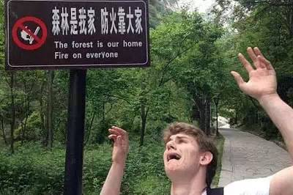
歪果游客从来不敢走进这片树林……
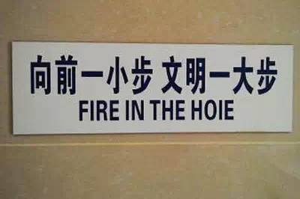
小编思考了一会，然后为这个简洁准确的翻译点了个zan！

麻麻，我真的不想去上学啊！
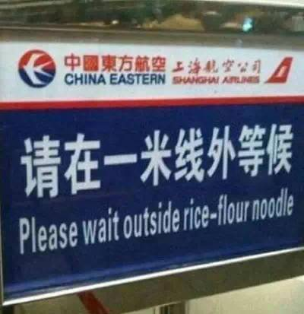
米线在中国为什么这么火！
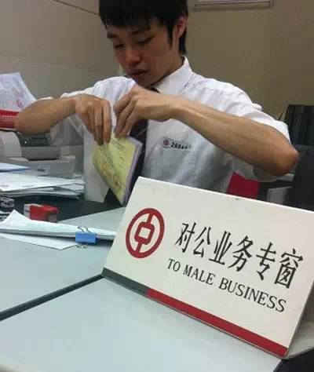
银行什么时候开始根据性别来区分顾客了？
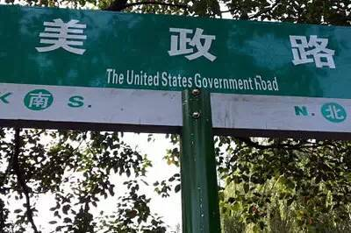
我走在这条路上，心里充满了期待。一会儿见到奥巴马，我该跟他说点什么呢？
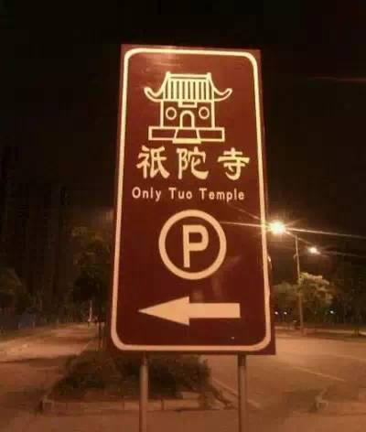
外国来的和尚也念不好这经啊……

这个就不解释了……
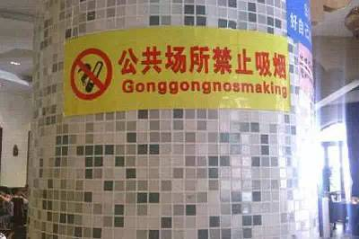
这一定是火星语，火星语！
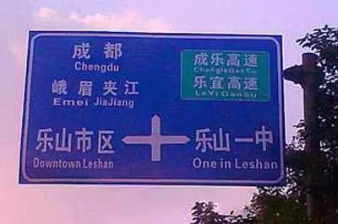
教育是头等大事！
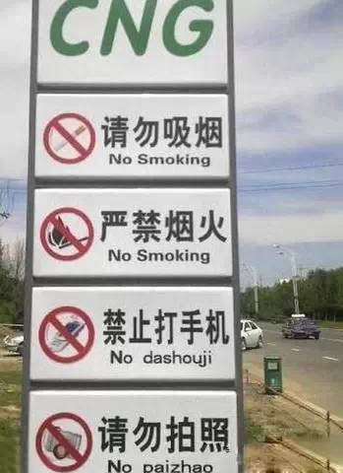
亲爱的歪果盆友，请根据上两块牌子来推测下边两块牌子的意思。

是小编想太多，还是最后两款口味重？画面太美不敢看……
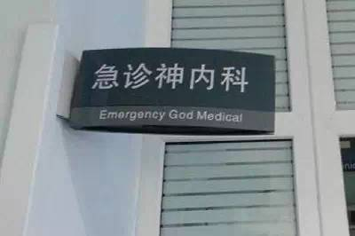
看到这块牌子，我顿时充满了痊愈的希望……
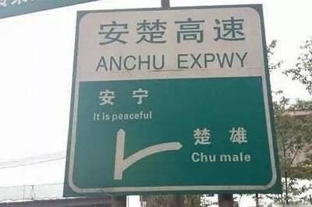
安宁是个好地方！
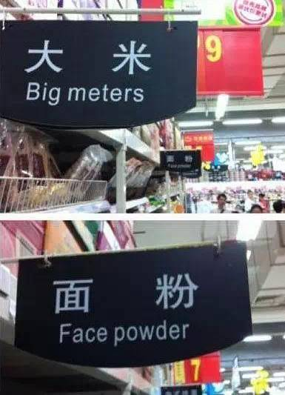
字斟句酌，精准到位！
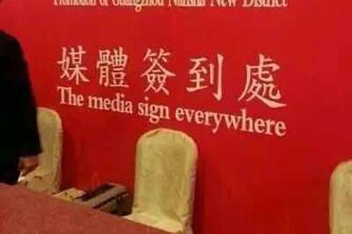
这是深刻揭露无良媒体的节奏么……
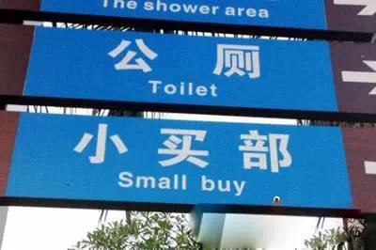
小买怡情，大买伤身，强买灰飞烟灭……
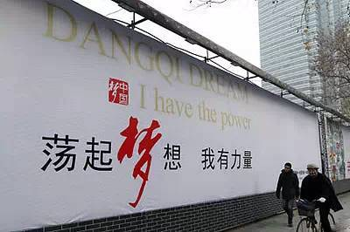
“荡起”这个词已经高大上到无法用英文来翻译了！
